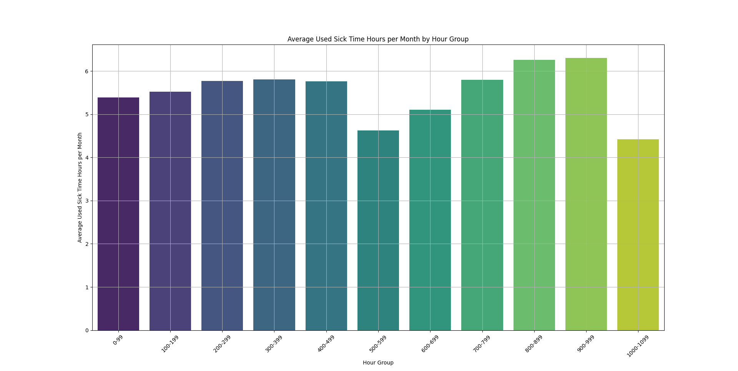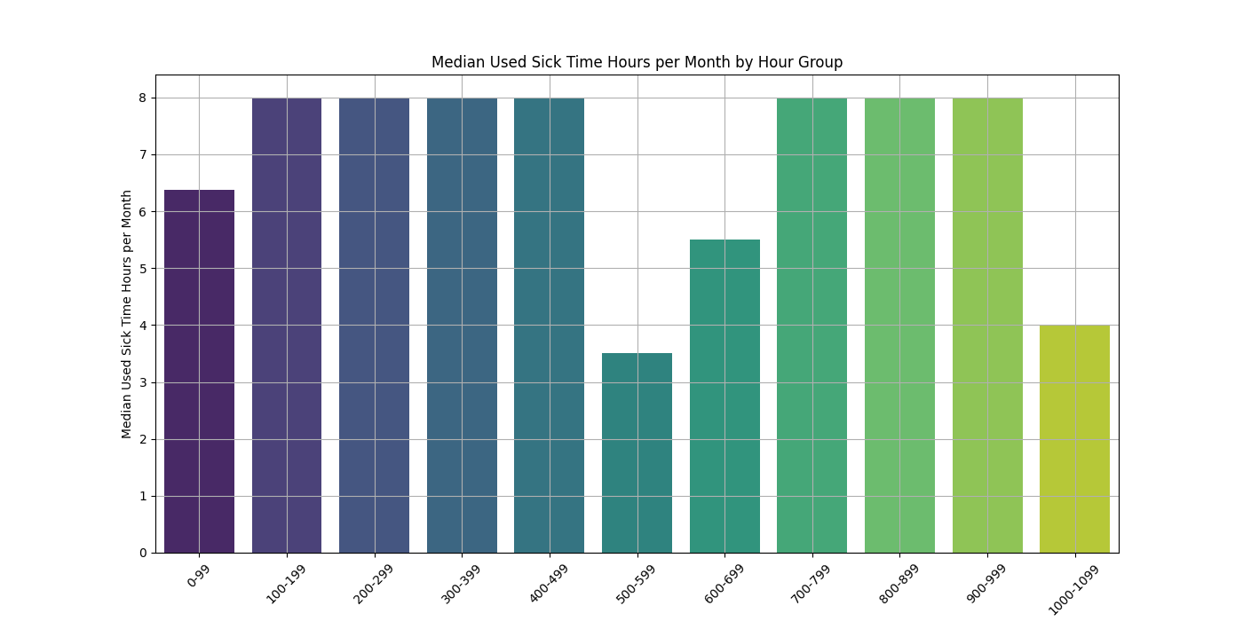Analysis of Average Used Sick Time Hours per Month by Hour Group
This document provides an in-depth analysis of the average used sick time hours per month for each hour group.

Relevant Metrics for Each Hour Group
Hour Group | Mean | Median | Standard Deviation | Minimum | Maximum | Count
0-99 | 5.385061 | 6.37 | 3.019935 | 0.0012 | 24.0 | 11496
100-199 | 5.563674 | 8.0 | 2.995642 | 0.11 | 12.0 | 5375
200-299 | 5.748748 | 8.0 | 2.971782 | 0.33 | 13.5 | 3426
300-399 | 5.835304 | 8.0 | 2.925475 | 0.5 | 14.0 | 1972
400-499 | 5.761536 | 8.0 | 3.175358 | 0.5 | 13.5 | 1712
500-599 | 4.571543 | 3.5 | 3.176598 | 0.5 | 13.5 | 1251
600-699 | 5.23972 | 5.5 | 3.264032 | 0.5 | 12.0 | 1216
700-799 | 5.714678 | 8.0 | 2.99354 | 0.5 | 13.33 | 729
800-899 | 6.259561 | 8.0 | 3.247728 | 0.5 | 24.0 | 842
900-999 | 6.531209 | 8.0 | 3.364573 | 0.25 | 40.0 | 860
1000-1099 | 4.535908 | 4.0 | 3.122211 | 0.25 | 13.0 | 589

Analysis
The table above shows the relevant metrics for each hour group in terms of used sick time hours per month.
1. The mean used sick time hours per month ranges from approximately 4.54 hours (for the '1000-1099' hour group) to approximately 6.53 hours (for the '900-999' hour group).
2. The median used sick time hours per month is consistently around 8 hours for most hour groups except for the '500-599', 600-699, and '1000-1099' hour groups.
3. The standard deviation indicates the variability in used sick time hours within each hour group.
4. The minimum and maximum values show the range of used sick time hours within each hour group.
5. The count represents the number of observations in each hour group.

Outliers
Outliers are identified using the Interquartile Range (IQR) method.
Hour Group | Mean | Median | Standard Deviation | Minimum | Maximum | Count
500-599 | 4.571543 | 3.5 | 3.176598 | 0.5 | 13.5 | 1251
900-999 | 6.531209 | 8.0 | 3.364573 | 0.25 | 40.0 | 860
1000-1099 | 4.535908 | 4.0 | 3.122211 | 0.25 | 13.0 | 589

Trends and Insights
Based on the analysis of the data:
- The groups with the lowest mean used sick time hours per month are the '500-599' and '1000-1099' hour groups.
- The groups with the highest mean used sick time hours per month are the '900-999' and '800-899' hour groups.
- The median used sick time hours per month is consistently around 8 hours for most hour groups except for the '500-599', 600-699 and '1000-1099' hour groups.

